Name:B.Alekhya

Reg no:192411010

CO4 ASSESMENT 2

Q5. Dijkstra – Navigation System

Introduction
Dijkstra’s Algorithm is a shortest-path algorithm used to find the minimum-cost path from a source location to all other locations in a weighted graph. In a navigation system, locations are represented as vertices (nodes) and roads are represented as edges. The edge weight can represent distance, travel time, fuel consumption, or another cost.
Dijkstra’s algorithm is suitable when all edge weights are non-negative.

Step-by-Step Execution
Consider locations A, B, C, D, and E connected by roads.
- Initialize distances
  - Set the source location distance to 0.
  - Set the distance of every other location to infinity.
  - Maintain a visited set to track finalized locations.
- Use a Priority Queue
  - Insert the source node with distance 0.
  - The priority queue always returns the node having the smallest tentative distance.
- Select the minimum-distance node
  - Remove the node with the smallest distance from the priority queue.
  - If it has not already been finalized, process its neighboring locations.
- Relax the edges
  - For each neighbor, calculate:
new_distance = current_distance + edge_weight
  - If the new distance is smaller than the previously stored distance, update it and insert the new value into the priority queue.
- Repeat the process
  - Continue selecting the minimum-distance node and relaxing its edges.
  - Once a node is finalized, its shortest distance from the source is known.
- Construct the shortest route
  - Store a parent or previous node whenever a distance is updated.
  - Starting from the destination, follow the parent nodes backward to reconstruct the shortest route.

Example
Suppose the roads have the following weights:
- A → B = 4
- A → C = 2
- C → B = 1
- B → D = 5
- C → D = 8
- D → E = 2
Starting from A:
Step | Selected Node | Shortest Distances
1 | A | A=0, B=4, C=2, D=∞, E=∞
2 | C | A=0, B=3, C=2, D=10, E=∞
3 | B | A=0, B=3, C=2, D=8, E=∞
4 | D | A=0, B=3, C=2, D=8, E=10
5 | E | A=0, B=3, C=2, D=8, E=10
Therefore, the shortest path from A to E is:
A → C → B → D → E
with total cost:
2 + 1 + 5 + 2 = 10

Priority Queue
A min-priority queue is important for efficient implementation. It stores nodes according to their current shortest tentative distance.
For example:
(0,A) → (2,C) → (3,B) → (8,D) → (10,E)
The node with the smallest distance is processed first.
In languages such as Python, a min-heap can be implemented using the heapq module. In C++, priority_queue can be configured as a min-heap.

Appropriate Data Structures
- Adjacency List – Efficiently stores neighboring locations and road weights.
- Priority Queue / Min-Heap – Quickly retrieves the location with the smallest tentative distance.
- Distance Array/Map – Stores the shortest known distance to each location.
- Parent Array/Map – Stores the previous location for reconstructing the route.
- Visited Set – Prevents unnecessary repeated processing of finalized nodes.
For large road networks, an adjacency list with a binary heap is generally more memory-efficient than an adjacency matrix.

Tools for Implementation
Suitable tools include:
- Python – heapq, lists, dictionaries, and sets.
- C/C++ – Arrays, structures, vectors, and priority queues.
- Java – PriorityQueue, ArrayList, and HashMap.
- Graph visualization tools – Useful for demonstrating nodes, roads, and shortest paths.
- GPS/map APIs – Can provide real-world road-network and routing data.

Time Complexity
The complexity depends on the data structures used.
Implementation | Time Complexity
Adjacency Matrix + Linear Search | O(V²)
Adjacency List + Binary Heap | O((V + E) log V)
Binary Heap, commonly stated | O(E log V)
Fibonacci Heap | O(E + V log V)
Where:
- V = number of locations/vertices
- E = number of roads/edges
For sparse real-world road networks, an adjacency list + binary heap is usually a practical choice.

Real-World Navigation Performance
Dijkstra’s algorithm provides reliable shortest paths when road costs are non-negative. However, modern navigation systems often have millions of roads and require results within milliseconds. Running ordinary Dijkstra from scratch for every request can therefore be expensive.
Real navigation systems improve performance using techniques such as:
- A* search with a geographic heuristic.
- Bidirectional search.
- Contraction hierarchies.
- Precomputed routing information.
- Dynamic traffic weights.
- Parallel and distributed processing.
For example, if traffic increases on a particular road, its edge weight can be increased to represent the additional travel time. The routing system can then calculate a route that avoids the congested road.
Output:
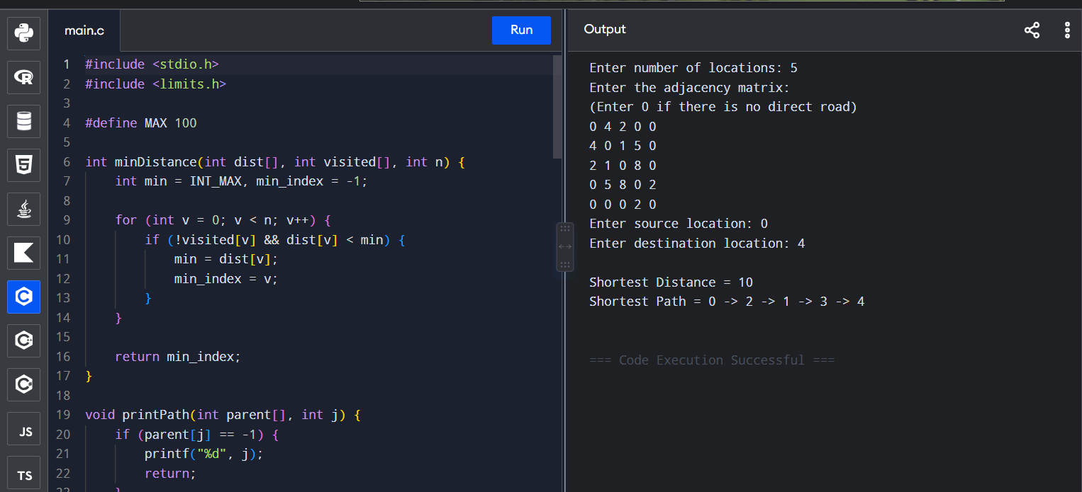

Conclusion
Dijkstra’s algorithm is an effective foundation for a navigation system because it guarantees the shortest path for graphs with non-negative edge weights. A priority queue, adjacency list, distance array, parent array, and visited set provide an efficient implementation. For small and medium-sized graphs, Dijkstra performs well, while large-scale navigation systems generally combine its ideas with algorithms such as A* and specialized route-planning techniques to achieve real-time performance.

